**Global Terrorism Analysis**

**Pratik Gumble**

**Data science trainee,**

**AlmaBetter, Bangalore**

**Abstract:**

There are certain terrorist organization to continuously take part of terrorist attacks which related in terms of certain distinguishable characteristics Therefore, there must be some patterns or informal rules guiding the activities of terrorist organizations. After analyzing these characteristic patterns of activity by terrorist organizations, authorities can make more detailed predictions and analyses of terrorist organizations to attack them more accurately and increase the time available for the prevention and prediction of terrorist attacks.

One of the greatest challenges a data scientist faces is knowing when to move on. It may be doing more Exploratory Data Analysis(EDA), it may be adjusting your model’s parameters for a better score, or simply trying to make your notebook look as professional as possible.

***Keywords: machine learning, Exploratory Data Analysis (EDA)***

**1.Problem Statement**

As a data scientist to perform exploratory data analysis to uncover the underlying structure. The analysis and prediction of terrorist attacks on terrorist groups provide valuable information for antiterrorism and terrorism prevention operations, to improve the security and stability of social life.

**2. Introduction**

After “9/11” attacks which was shorthand for four coordinated terrorist attacks carried out by al-Qaeda, an Islamist extremist group, that occurred on the morning of September 11, 2001, all the peoples understood terrorism is not part of one region but it is global threat that knows no border, nationality or religion, and is a challenge that the international community must tackle together.

India in past faced many terrorist attacks, 2008 Mumbai attacks, Amaranth yatra attacks, Uri attacks, in most of the time in news channels we saw news about terrorist attacks in Jammu and Kashmir. Because of continuous bombardment of terrorist news, I have strong interest in topic of terrorism as why this happen, which is the most suffered countries, terrorist organization, their technique used for terrorism. As a data scientist I starts working on that datasets.

### The analysis and prediction of terrorist attacks on terrorist groups provide valuable information for antiterrorism and terrorism prevention operations, to improve the security and stability of social life.

There are certain terrorist organisation to continuously take part of terrorist attacks which related in terms of certain distinguishable characteristics Therefore, there must be some patterns or informal rules guiding the activities of terrorist organizations. After analyzing these characteristic patterns of activity by terrorist organizations, authorities can make more detailed predictions and analyses of terrorist organizations to attack them more accurately and increase the time available for the prevention and prediction of terrorist attacks.

One of the greatest challenges a data scientist faces is knowing when to move on. It may be doing more Exploratory Data Analysis(EDA), it may be adjusting your model’s parameters for a better score, or simply trying to make your notebook look as professional as possible.

The primary objective of exploratory data analysis in order to perform exploratory data analysis is to uncover the underlying structure. The structure of the various data sets determines the trends, patterns, and relationships among them

Therefore, performing an Exploratory Data Analysis allows data scientists to detect errors, debunk assumptions, and much more to ultimately select an appropriate predictive model.

## **3. Dataset and Data cleaning**

**Dataset:**

The Global Terrorism Database (GTD) is a database on terrorist attacks around the world from 1970 through 2016 containing over 150,000 observations. Researchers at the National Consortium maintain the database for the Study of Terrorism and Responses to Terrorism (START), headquartered at the University of Maryland.

**Data Processing**

This project is full scope of visualizations and all the information they do and do not present. Among the primary purposes of this project was to dive EDA visualizations surrounding time and what they demonstrate.

First step after loading data was Cleaning the data to remove unwanted data, missing values, rows, and columns, duplicate values, data type conversion, etc.

# After data inspection we found that there are 181691 rows × 135 columns available in the dataset so we only keep columns of our interest. For proper understanding rename some column of interest and drop other columns.

# **Variable Description**

**'Year':** Year of terrorist attacks,

**'Month':** Month of terrorist attacks

**'Day’:** Date of month of terrorist attacks

**'Country':** Country of terrorist attacks

**'Region':** Region of terrorist attacks

**'City':** City of terrorist attacks

**'Latitude':** Latitude of terrorist attacks

**'Longitude':** Longitude of terrorist attacks

**'Attack_Type':** Type of terrorist attacks

**'Summary':** A brief statement or account of the main points of terrorist attacks.

**'Target':** A person, object, or place selected as the aim of an attack.

**'Weapon_type':** Weapon used in terrorist attacks

**'Killed':** Number of people killed in terrorist attacks

**'Wounded':** Number of people wounded in terrorist attacks

**'Motive':** Motive of terrorist attacks

**'Terrorist_Group':** Name of terrorist group

‘**Success':** Terrorist successful attacks

## **4. Exploratory Data Analysis**

First we start to plot a bar plot for each numerical feature count present in our modified dataset.

Count plots and bar plots are two types of visualizations that Seaborn calls "categorical plots". Categorical plots involve a categorical variable, which is a variable that consists of a fixed, typically small number of possible values, or categories. These types of plots are commonly used when we want to make comparisons between different groups.

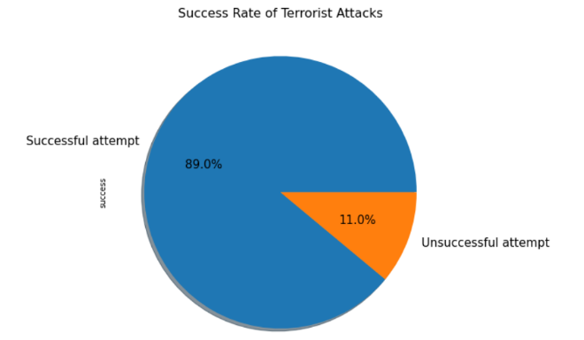

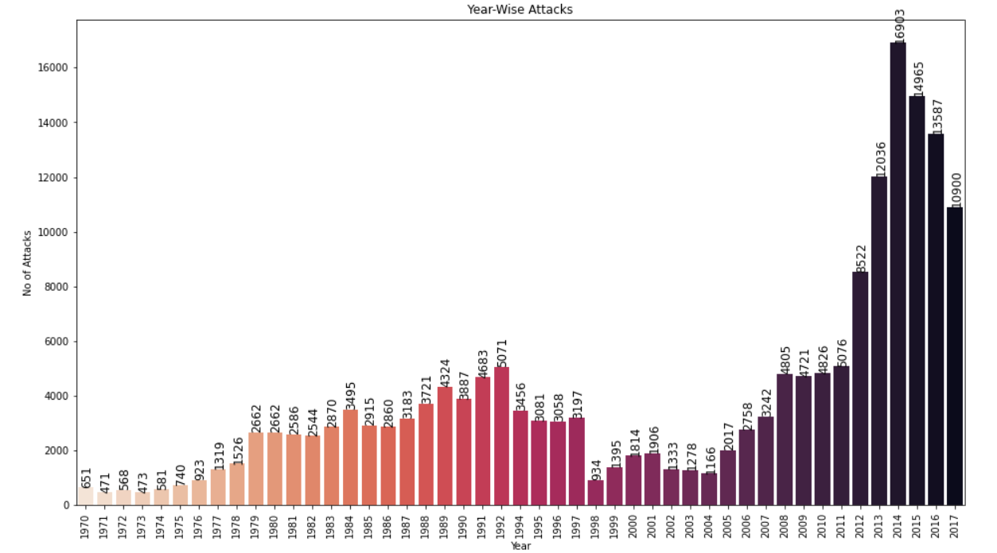

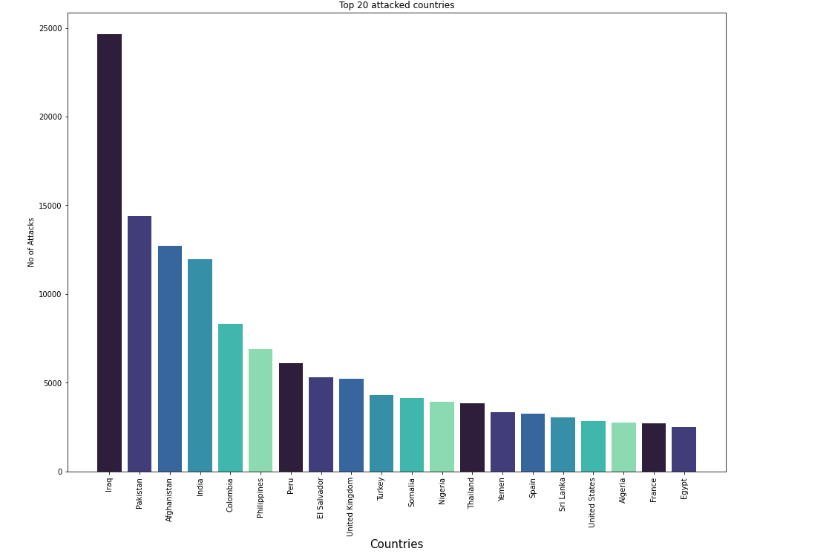

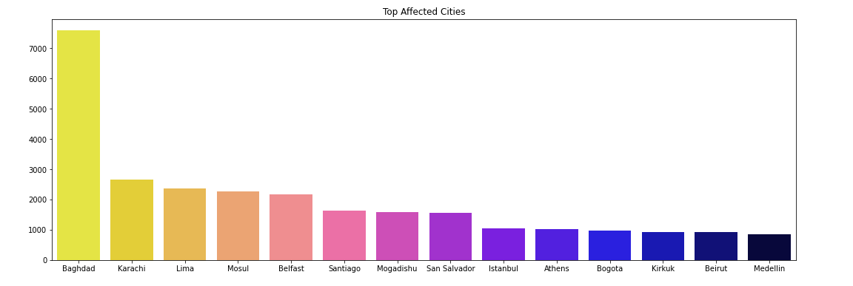

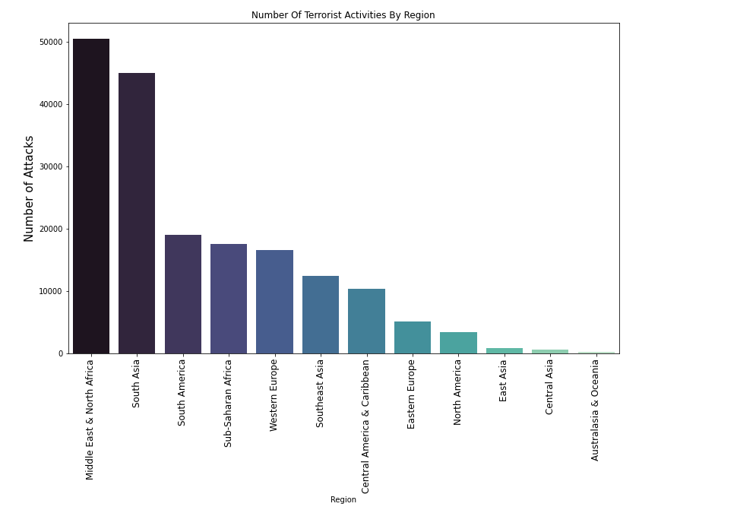

This graph represents the distribution of numeric data on each series in the Data Frame.

**Correlation Heatmaps**

Correlation heatmaps are a type of plot that visualize the strength of relationships between numerical variables. Correlation plots are used to understand which variables are related to each other and the strength of this relationship. A correlation plot typically contains a number of numerical variables, with each variable represented by a column. The rows represent the relationship between each pair of variables. The values in the cells indicate the strength of the relationship, with positive values indicating a positive relationship and negative values indicating a negative relationship. Correlation heatmaps can be used to find potential relationships between variables and to understand the strength of these relationships. In addition, correlation plots can be used to identify outliers and to detect linear and nonlinear relationships. The color-coding of the cells makes it easy to identify relationships between variables at a glance. Correlation heatmaps can be used to find both linear and nonlinear relationships between variables.

# .

The above correlation graph shows only two features wound and kills are just correlated but not highly correlated.

**Terrorist Activities (1970-2017)**

When initially looking at the data represents since 2012 to 2017 has large number of terrorist activities occurred. In 2014 almost 16903 terrorist activities took place in only one year which was maximum up to 2017.

We can see here that attacks slowly start to increase from 1970 until about 1997 where until 2004 we see a downward global trend in Terrorist incidents despite events like September 11, 2001.

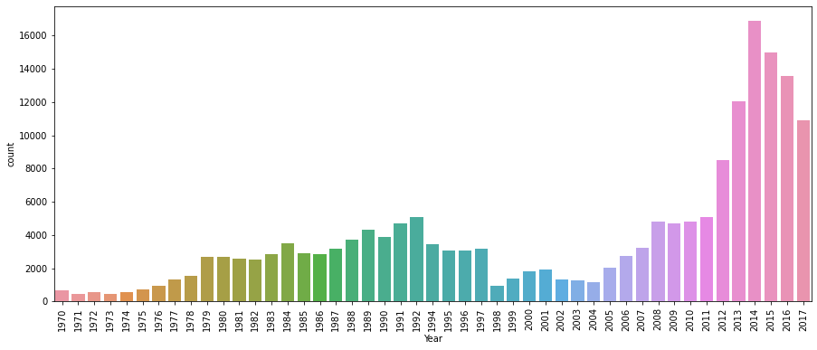

# **Terrorist Group**

Graph shows that there were unknown groups that take part in most of the terrorist activities. While Taliban and ISIS was the biggest Terrorist Group which take parts in most of the terrorist activities.

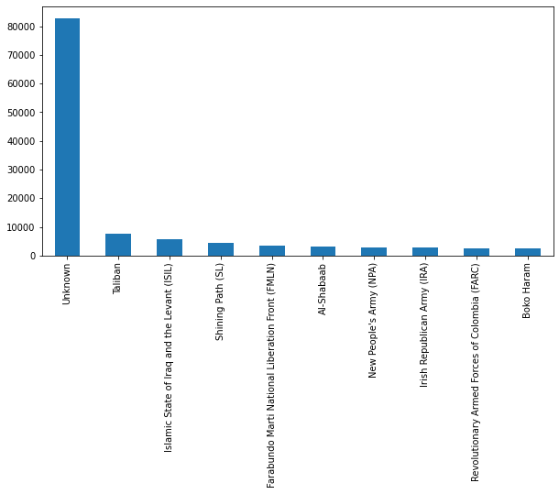

# **Attacks type**

Terrorist attacks type means which methods used by terrorist to attacks like bombing, armed assault, assassination, hijacking etc.

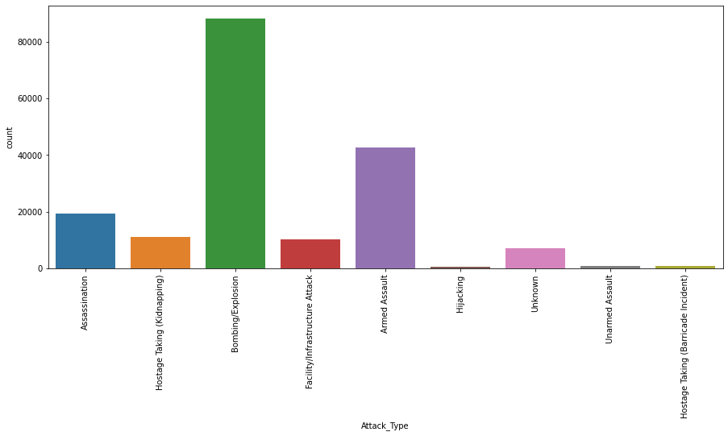Since from the above chart it is clear that Bombing/Explosion and armed assault was mostly used by terrorist for terrorist attacks. Here we can see that in the past 47 years the overwhelming favored form of attack has been bombings with it being the choice of terrorists more than twice that of Armed Assaults. Interestingly, hijacking is in last despite its prevalence in the 1970s and 1980s.

# **Weapon type**

# Weapon type means type of weapons used by terrorist for terrorist attacks.

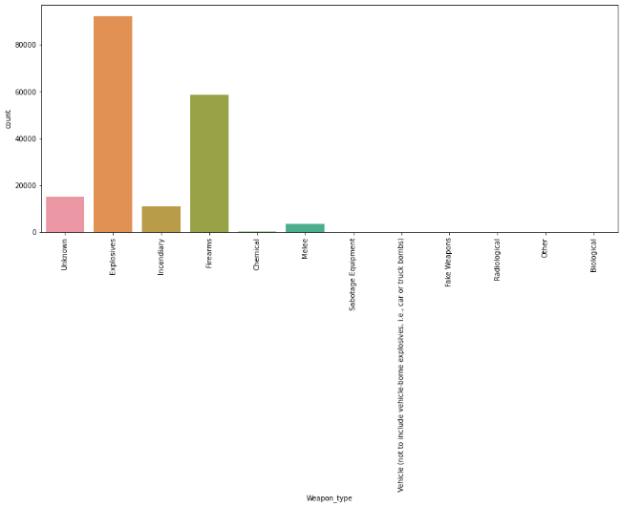From the above graph it is clear that explosives and firearms were mostly used by terrorist for terrorist attacks.

**Target**

Terrorist threats to soft targets, including critical infrastructure and public places ,attacks on urban centers, religious sites and places of worship, [major sports events](https://www.un.org/counterterrorism/sports) and [civilian aviation](https://www.un.org/cttravel/) are on the rise and terrorist groups have repeatedly called on their followers to target people in public spaces, which are especially easy or soft target due to their open and accessible nature.

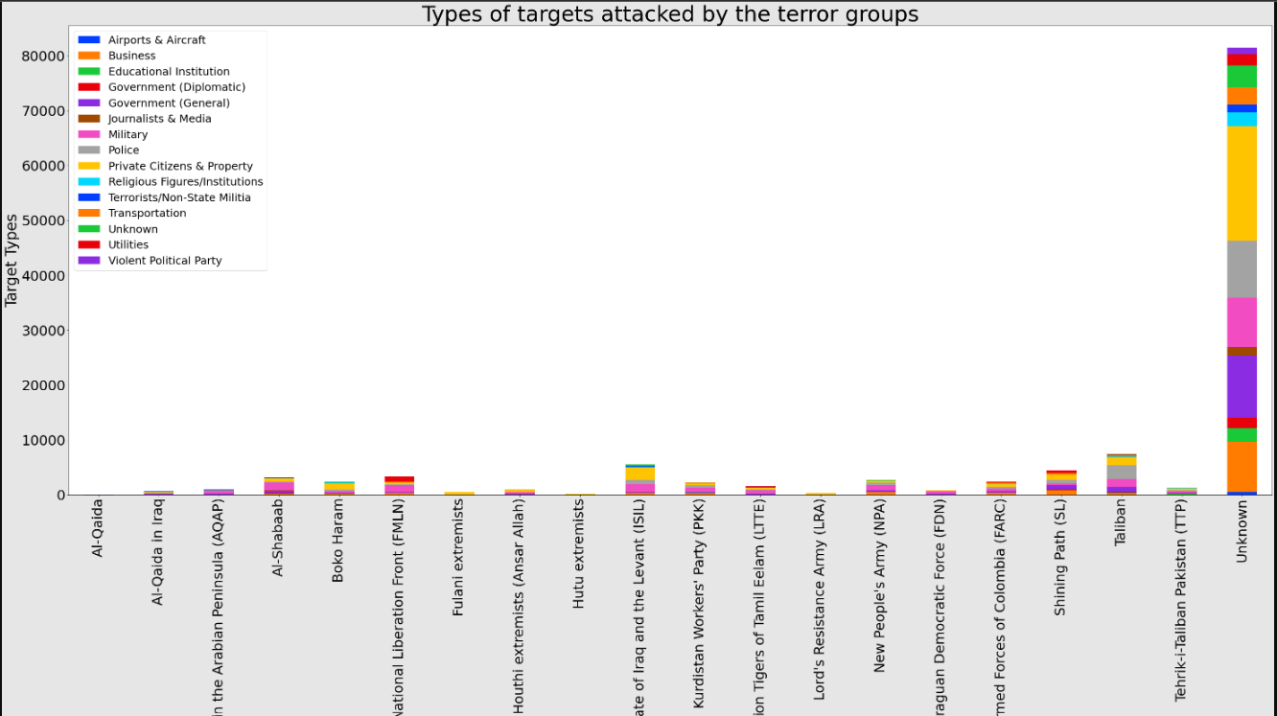

Here we can see that in the past 47 years the overwhelming favored form of target has been private citizens and property with it being the choice of terrorists more than twice that of government.

**Number of Causalities in countries with year**

Below, we see a chart of the type of attacks with years by number of injured and by numbers killed with the size of the circle being the number of occurrences. We can see over whelmingly that the most frequent target is civilians who as a result also suffer the most at the hands of terrorists.

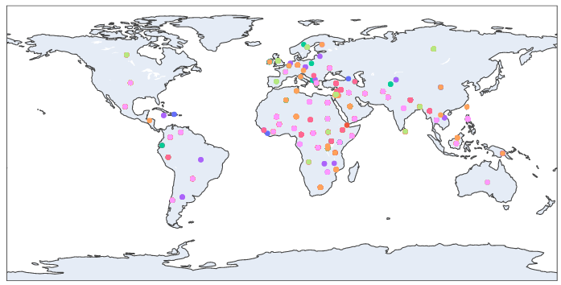

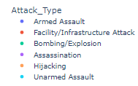

# **Analysis of terrorist attacks by country, city and region**

In this chart, we see the number of attacks from terrorism by country and region. Most of the terrorist attacks occurred in the Middle East & North Africa. Less than 2% of terrorist attacks were in Central Asia, East Asia, Central America and Caribbean the Americas and Australia and Oceania combined. While Iraq has suffered the maximum number of terrorist attacks of 8850 Belize has suffered the minimum number of terrorist attacks of 1

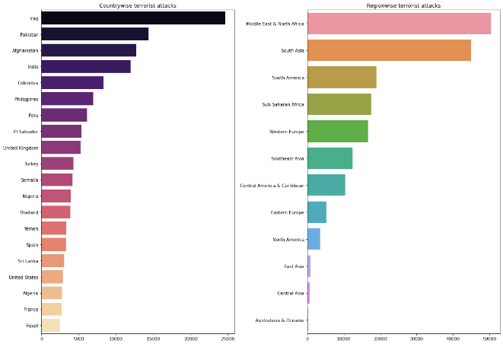

# This is also true when we look at the city, rather than the country. Bagdad and Mosul was most suffered cities of terrorist attacks. As we will see in the following section, not only is there a strong regional focus but this is also heavily concentrated in only a few cities within these regions.

**Highest Number of Death Casualties with Year due to Terrorist Attacks**

Terrorism is often regionally-focused. But within these regions, it’s also concentrated within specific countries. Middle East Asia and South Asia had by far the largest number of deaths particularly in Iraq (34945 peoples), Pakistan (12405 peoples) Afghanistan(9423 peoples) and India( peoples 8312) was killed during 1970 to 2017.

# C:\Users\Dell\AppData\Local\Microsoft\Windows\INetCache\Content.Word\download (16).png

# **Terrorism Analysis in India**

# Terrorism in India, according to the [Home Ministry](https://en.wikipedia.org/wiki/Ministry_of_Home_Affairs_(India)), poses a significant threat to the people of India. Compared to other countries, India faces a wide range of terror groups. Terrorism found in India includes [Islamic terrorism](https://en.wikipedia.org/wiki/Islamic_terrorism), [separatist terrorism](https://en.wikipedia.org/wiki/Nationalist_terrorism), and [left-wing terrorism](https://en.wikipedia.org/wiki/Left-wing_terrorism) .India is one of the countries most impacted by terrorism.

India continues to face a number of terror attacks from Islamic groups in [Kashmir](https://en.wikipedia.org/wiki/Kashmir), [Sikh separatists](https://en.wikipedia.org/wiki/Khalistan_movement) in [Punjab](https://en.wikipedia.org/wiki/Punjab,_India), and secessionist groups in [Assam](https://en.wikipedia.org/wiki/Assam).

# The regions with long term [terrorist](https://en.wikipedia.org/wiki/Terrorist) activities have been [Jammu and Kashmir](https://en.wikipedia.org/wiki/Jammu_and_Kashmir_(union_territory)), east-central and south-central India ([Naxalism](https://en.wikipedia.org/wiki/Naxalite)) and the [Seven Sister States](https://en.wikipedia.org/wiki/Seven_Sister_States).

# So it was important for me to analysis of terrorism in India.

# ***Most Affected Cities, States and region by Terrorism***

From the chart it was clear that Communist Party of India-Moist(CPI-Moist) was biggest terrorist group in India and Jammu & Kashmir. While Kashmir and Punjab most suffered terrorist state in India. Jammu & Kashmir, Panjab and Assam was the India’s states most impacted by [terrorism](https://www.business-standard.com/topic/terrorism) during 1970 to 2017, most of which were perpetrated by the [Hizbul Mujahideen](https://www.business-standard.com/topic/hizbul-mujahideen) (HM), [Jaish-e Mohammad](https://www.business-standard.com/topic/jaish-e-mohammad) (JeM) and [Lashkar-e-Taiba](https://www.business-standard.com/topic/lashkar-e-taiba) (LeT).

“Both JeM and LeT have also been active in Pakistan and Afghanistan, though most of their attacks are carried out in India,” notes the report.

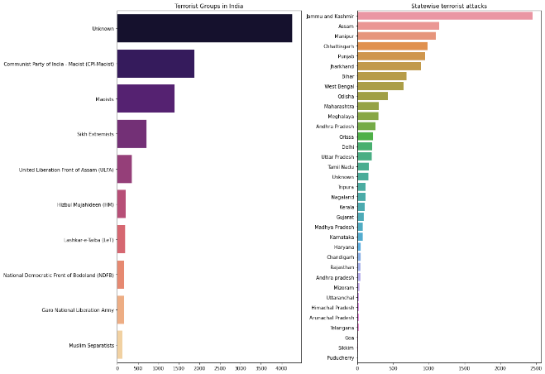

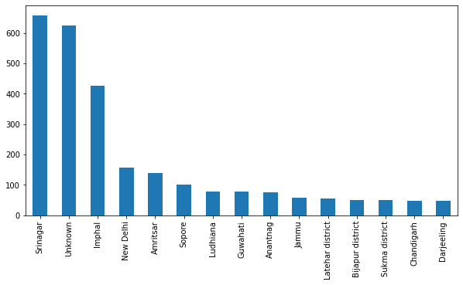

# From the above chart it is clear that Shrinagar was mostly suffered city by terrorist attacks.

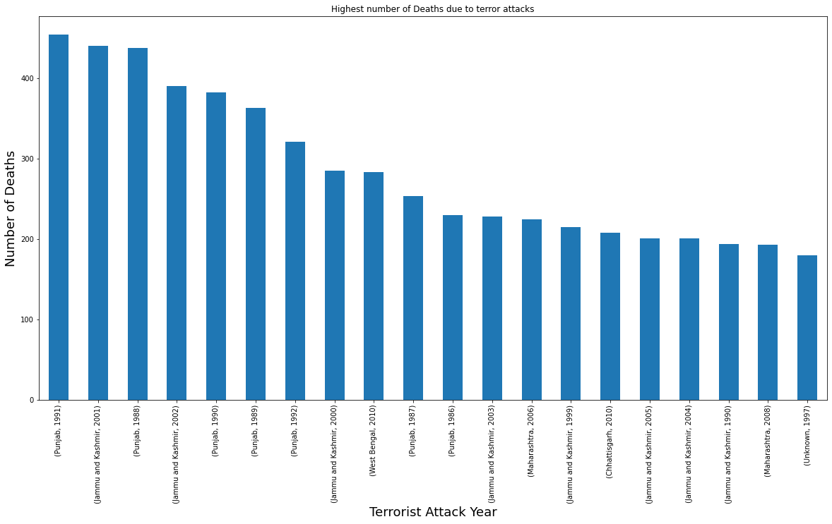

**8. Conclusion:**

* Attacks were more during 2014 it almost 16903 and then in 2015. When compared to attacks from 1970 onwards, the last 6 years scored a maximum i.e. 42 % with respect to terrorist attacks from 1970. But from 2014 onwards count started decreasing.
* Most of the terrorist attacked carried out by unknown groups mostly in Iraq, Pakistan and Afghanistan. While Taliban and ISIS was the biggest Terrorist Group which take parts in most of the terrorist activities.
* Most of the attacks were attacked through explosives and then through firearms.
* Iraq dominates all the countries and it has the highest number of attacks and then Pakistan, Afghanistan, and India follow it.
* Also Baghdad dominates all the cities and it has the highest number of attacks and then Mosul, Karachi follow it.
* The Middle East& North Africa leads 1st among all the regions and then South Asia takes 2nd place.
* For most of the attacks, the target is Private Citizens& property and the next Military leads.
* Most of the attacks were through either Bombing or Explosion.

**References-**

1. MachineLearningMastery
2. GeeksforGeeks
3. Analytics Vidhya